Yuan Jingtian

Data Analysis

**Task 2**

**Statistical Hypothesis**

**Dataset “data_for_analysis”**

1. **estimate the distribution of continuous variables in data by group (outcome)**

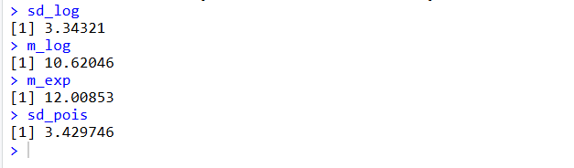

normal distribution

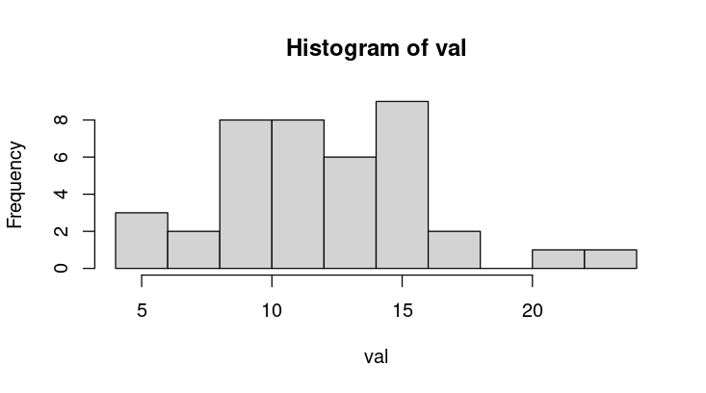

lognormal distribution

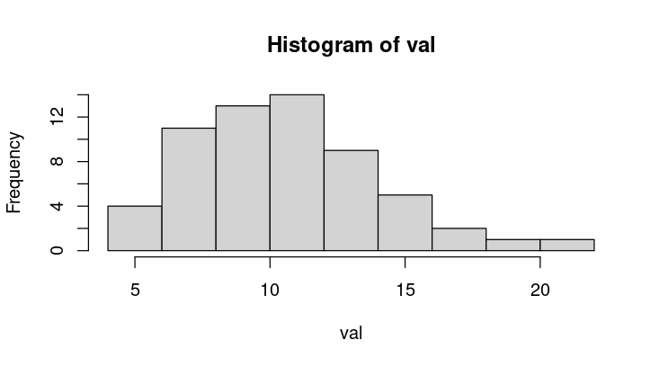

exponential distribution

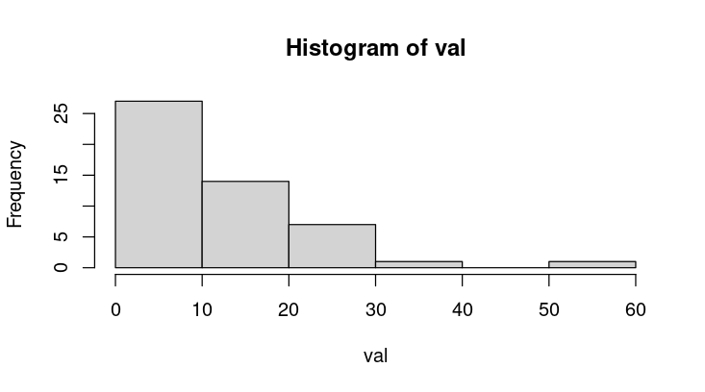

Poisson distribution

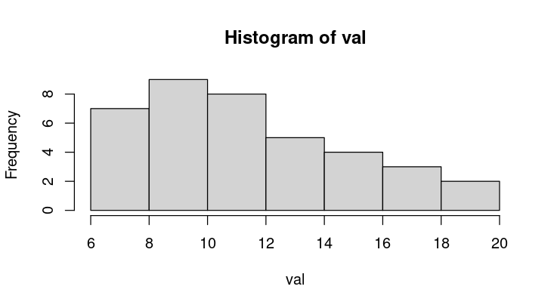

1. **create a table with descriptive statistics and specify the parameters according to the selected distribution (by group)**

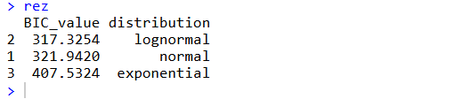

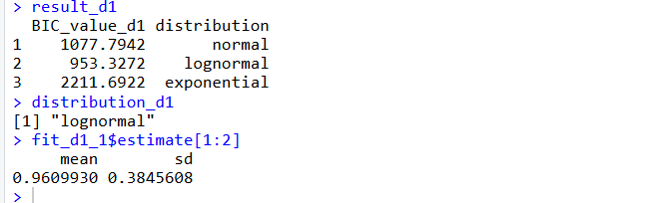

#---------------Creating a custom table--------------

# Homework: Creating a custom table with descriptive statistics results

calculate_stats <- function(x) {

if (is.numeric(x)) {

data.frame(

N = length(x),

Mean = mean(x, na.rm = TRUE),

SD = sd(x, na.rm = TRUE),

Median = median(x, na.rm = TRUE),

IQR = IQR(x, na.rm = TRUE),

Min = min(x, na.rm = TRUE),

Max = max(x, na.rm = TRUE),

Missing = sum(is.na(x))

)

} else {

data.frame(

N = length(x),

Categories = length(unique(x)),

Most_Frequent = names(sort(table(x), decreasing = TRUE))[1],

Freq = max(table(x)),

Missing = sum(is.na(x))

)

}

}

# Select the variables we want to include in our table

vars_to_analyze <- c("lipids1", "lipids2", "lipids3", "lipids4")

# Apply the function to each variable and combine results

stats_list <- lapply(data_for_analysis[vars_to_analyze], calculate_stats)

# Combine all results into one table

custom_stats_table <- do.call(rbind, stats_list)

# Add variable names as a column

custom_stats_table <- cbind(Variable = rownames(custom_stats_table), custom_stats_table)

rownames(custom_stats_table) <- NULL

# Format the table nicely

custom_stats_table <- as.data.frame(custom_stats_table)

# Print the table

print(custom_stats_table)

# Optionally, save to CSV

write.csv(custom_stats_table, "custom_descriptive_stats.csv", row.names = FALSE)

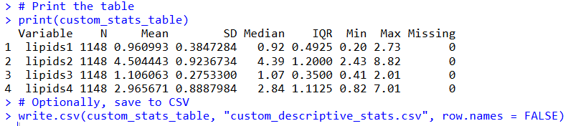

1. **perform the Brunner-Munzel test for 2 independent groups (enter the p-value into the data description table)**

